**Database Design-Package Diagram**

**Version 1.0**

**Project Management App**

**Team A**

**CSC-355**

**Spring 2016**

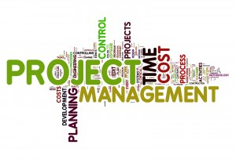

02/19/2016

Author: Tyler Mariano – System Designer & Jennifer Li – Project Leader

Submitted To: Dr. Joo Tan

**TABLE OF CONTENTS**

Revision History…………………………………………………………………………………..ii

1.0 Introduction……..….....…………………………….…...…………………………….……....1

2.0 Database System………………………………………………………………………………1

2.1 Overview………………………………………………………………………………..

2.2 Type of Database……………………………………………………………………….

2.3 Tables and Attributes…………………………………………………………………...

2.4 ER Diagram…………………………………………………………………………….

2.5 Table Details…………………………………………………………………………....

2.5.1 UserTable…………………………………………………………………….

2.5.2 ProjrctTable…………………………………………………………………..

2.5.3 TaskTable…………………………………………………………………….

2.5.4 ProgressTable………………………………………………………………...

**REVISION HISTORY**

|  |  |  |  |
| --- | --- | --- | --- |
| Version | Author | Description | Date |
| 1.0 | Jennifer Li | I created the first draft. | 1/31/2016 |
|  | Jennifer Li | Created tables outlines | 02/15/2016 |
|  | Jennifer Li | Added Section 1 and 2.2 | 02/16/2016 |

**1.0 INTRODUCTION**

The purpose of this document is to explain the design of the Project Management App database, show the relationships between each of the database entities, and illustrate how they interact with the application. This document also illustrates details regarding the software and technologies that will be implemented.

**2.0 Database System**

Stuff

**2.1 Overview**

stuff

**2.2 Type of Database**

The type of database used in the Project Management App is a relational database. It has a total of 4 tables ( for now), each table is important for application use. The tables are as follows: UserTable, ProjectTable, TaskTable, ProgressTable.

**2.3 Tables and Attributes**

Below is a chart showing each table and its attribute.

|  |  |
| --- | --- |
| Table | Attributes |
| UserTable | UserID (primary key), FirstName, LastName, Email, Password, Bio, ProjectList, Picture |
| ProjectTable | ProjectID (primary key), Leader, MemberList, Name, Description, Progress |
| TaskTable | TaskID (primary key), UserID, ProjectID, Description, Progress, Status, Priority, DueDate, Dependency |
| ProgressTable | ProgressID (primary key), UserID, ProjectID, TaskID, Progress |

**2.4 Relationships**

Below is an ER Diagram showing each table and its relationship to other tables.

(This diagram was made using _______ )

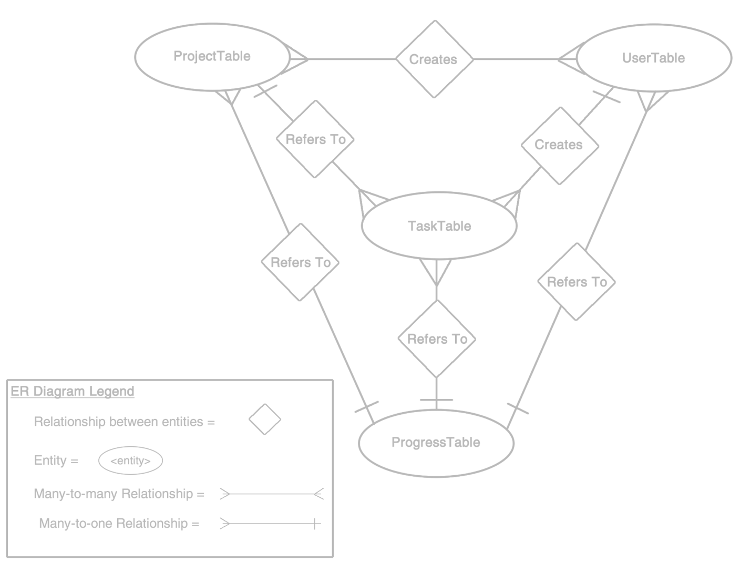

**2.5 Table Details**

This section contains a brief description of each table and a chart, documenting its attributes, attribute types, and attribute descriptions.

**2.5.1 UserTable**

descriptions.

|  |  |  |
| --- | --- | --- |
| Attributes | Data Type | Description & Example |
| UserID | INTEGER (Size) | Primary key – (Example) |
| FirstName | TEXT (Size) | – (Example) |
| LastName | TEXT (Size) | – (Example) |
| Email | TEXT (Size) | Required Unique– (Example) |
| Password | TEXT (Size) | Required– (Example) |
| Bio | TEXT (Size) | – (Example) |
| ProjectList | TEXT (Size) | – (Example) |
| Picture | BLOB (Size) | Used to hold image URL– (Example) |

**2.5.2 ProjectTable**

descriptions.

|  |  |  |
| --- | --- | --- |
| Attributes | Data Type | Description & Example |
| ProjectID | INTEGER (Size) | Primary key – (Example) |
| LeaderList | TEXT (Size) | Required Foreign key– (Example) |
| MemberList | TEXT (Size) | Comma separated array of UserID from UserTable – (Example) |
| TaskList | TEXT (Size) | Comma separated array of TaskID from TaskTable – (Example) |
| ProjectName | TEXT (Size) | Required– (Example) |
| ProjectDescription | TEXT (Size) | Required– (Example) |

**2.5.3 TaskTable**

descriptions.

|  |  |  |
| --- | --- | --- |
| Attributes | Data Type | Description & Example |
| TaskID | INTEGER (Size) | Primary key– (Example) |
| UserID | INTEGER (Size) | Required Foreign key– (Example) |
| ProjectID | INTEGER (Size) | Required Foreign key– (Example) |
| TaskName | TEXT (Size) | Required– (Example) |
| TaskDescription | TEXT (Size) | Required– (Example) |
| TaskProgress | REAL (Size) | – (Example) |
| TaskStatus | TEXT (Size) | – (Example) |
| TaskPriority | INTEGER (Size) | Required– (Example) |
| TaskDueDate | TEXT (Size) | Required– (Example) |

**2.5.3 ProgressTable**

descriptions.

|  |  |  |
| --- | --- | --- |
| Attributes | Data Type | Description & Example |
| ProgressID | INTEGER (Size) | Primary key– (Example) |
| UserID | INTEGER (Size) | Foreign key– (Example) |
| ProjectID | INTEGER (Size) | Foreign key– (Example) |
| TaskID | INTEGER (Size) | Foreign key– (Example) |
| AllTaskProgress | REAL (Size) | – (Example) |